VISUALIZATION TOOL FOR

ELECTRIC VEHICLE

1. INTRODUCTION
   1. Overview

An EV is a shortened acronym for an electric vehicle. EV are vehicles that are either partially or fully powered on electric power. Electric vehicles have low running costs as they have less moving parts for maintaining and also very environmentally friendly as they use little or no fossil fuels (petrol or diesel).

An EV includes both a vehicle that can only be powered

by an electric motor that draws electricity from a

battery (all-electric vehicle) and a vehicle that can be

powered by an electric motor that draws electricity from

a battery and by an internal combustion engine (plug-in

hybrid electric vehicle).

1.2 PURPOSE

Use of this ProjectElectric vehicles use electricity to charge their

batteries instead of using fossil fuels like petrol or

diesel. Electric vehicles are more efficient, and that

combined with the electricity cost means that charging

an electric vehicle is cheaper than filling petrol or diesel

for your travel requirement

2. Problem Definition and Design

Thinking

The supply of electric isn’t consistent in many parts of the country, and charging larger batteries requires higher capacity and voltage.

3. Result





















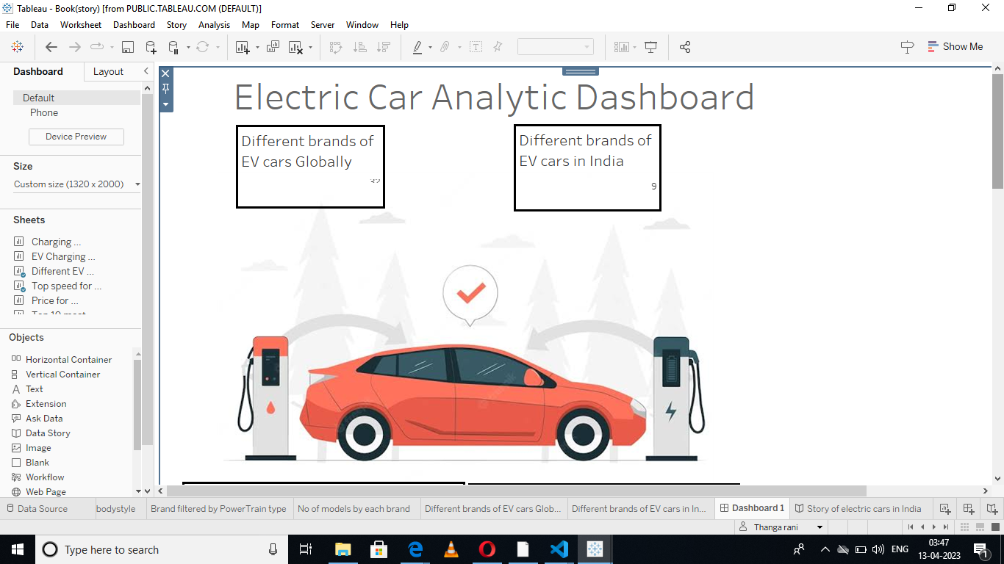

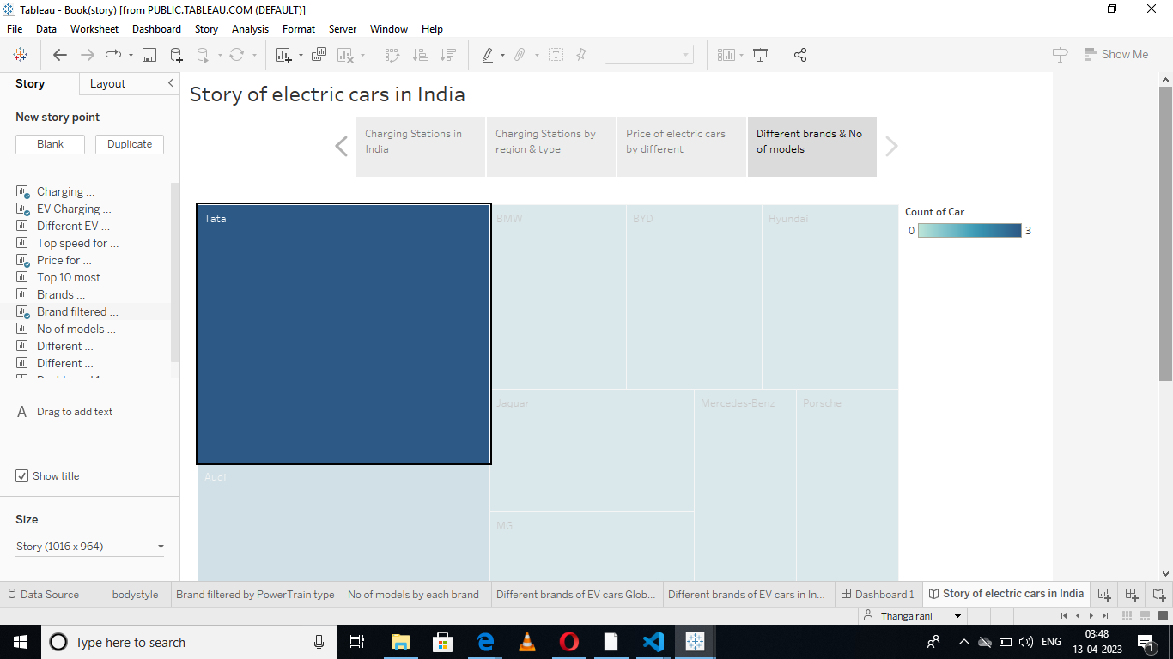

4. ADVANTAGES AND DISADVANTAGES OF

THE ELECTRIC VEHICLE

1.ELECTRIC CARS ARE ENERGY EFFICIENT

Energy efficient refers to the amount of energy from the fuel source

that is converted into actual energy for powering the wheels of a vehicle.

AEVs like offerings from Tesla are far more efficient than conventional

gas-powered vehicles: AEV batteries convert 59 to 62 percent of energy

into vehicle movement while gas powered vehicles only convert between

17 and 21 percent. This means that charging an more towards actually powering the vehicle than filling a gas tank.

2. ELECTRIC CARS PERFORM WELL AND DON’T NEED MUCH MAINTENANCE

All-electric vehicles are also high performance vehicles whose motors

are not only quiet and smooth but require less maintenance than internal

combustion engines such as an oil change. The driving experience can

also be fun because AEV motors react quickly, making them responsive

with good torque. AEVs are overall newer than their gas powered counterparts and are often more digitally connected with charging stations, providing options such as controlling charging from an app.

**DISADVANTAGES OF ELECTRIC CARS**

Electricity storage is still expensive . Battery charging is time consuming. Primary resources depletion for some elements of the LIB. Sufficient public charging infrastructure is still lacking. Lacks of the power to accelerate and climb quickly.

,

5. APPLICATIONS

Among all of the challenges faced by the EV

industry, the most prominently reported problems

are low mileage of the vehicles, higher costs, lack

of service centers, unawareness about maintenance and servicing, unclear policies, supply chain problems, and insufficient charging stations.

6. Conclusion:

After doing this project, we have realised the

Challenges faced with Electric vehicles and more about Electric vehicle.

Moreover, EV vehicle is better than petrol cars as a point of us after doing this project.

**7. FUTURE SCOPE;**

The Indian electric vehicle market was worth USD 1,434.04 million in

2021, and it is predicted to grow to USD 15,397.19 million by 2027

a CAGR of 47.09% during the forecast period (2022-2027).

The Indian automobile industry is the world’s fifth biggest, and it is

anticipated to become the third largest by 2030. According to the India

Energy Storage Alliance (IESA), the Indian EV market would develop at

a 36% CAGR.

the country imports over As India’s population grows and demand for automobiles increases,

reliance on conventional energy supplies is no longer a viable option, as

80% of its crude oil.

By 2030, NITI Aayog expects to reach 70% EV market penetration for all

commercial vehicles, 30% for private vehicles, 40% for buses, and 80%

for two and three-wheelers. This is consistent to reach net zero carbon

emissions by 2070.

Appendix:

All the electric vehicles need to be registered and have a valid number plate before you take them out on the streets of India.

